I
- Implement a randomized Quick Sort and compare its performance with the standard Quick Sort.
CODE:
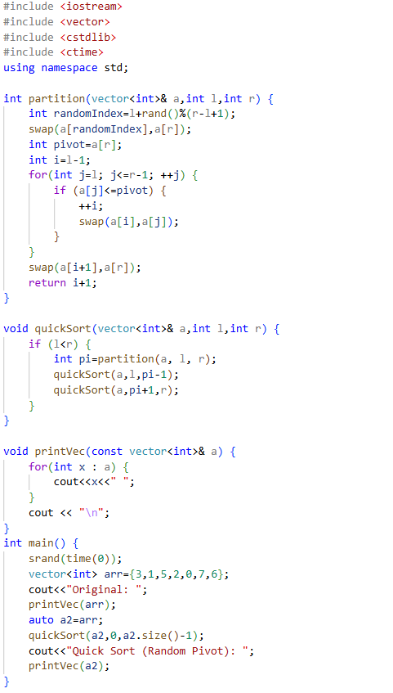
Output:
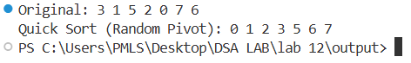

Simple Quick Sort | Random Pivot Quick Sort
Pivot = last element | Pivot = random element
Easy to implement | Greatly reduces chance of worst-case
Can become very slow if the array is already sorted | Much more efficient on real-world data
Worst-case time = O(n²) | Worst-case still possible but very rare
Average time = O(n log n) | Average time = O(n log n) (more stable)
More predictable but less efficient on bad inputs | Better distribution of pivots
Used mainly for teaching or simple cases | Preferred for competitive programming and real applications

2. Modify Merge Sort to work with linked lists.
CODE:
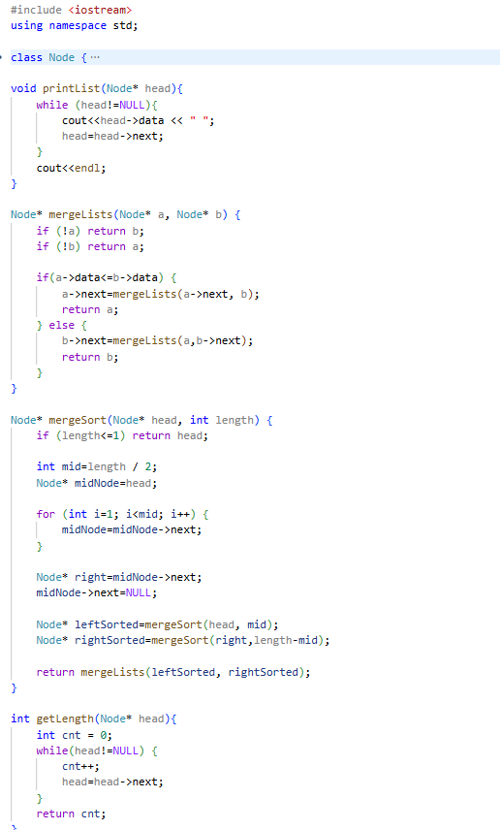
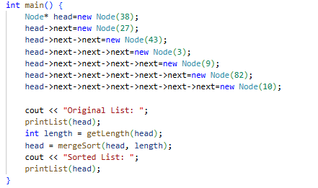

Output:
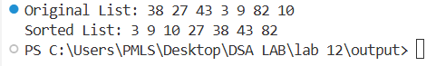

- Identify which algorithm performs better for nearly sorted data and explain why.
For nearly sorted data, Merge Sort is usually better if Quick Sort always picks the first or last element as the pivot. This is because Quick Sort can become very slow on nearly sorted arrays when it chooses a fixed pivot. In such cases, one side of the partition has almost all the elements while the other side is nearly empty, which makes Quick Sort do a lot of unnecessary steps and its time becomes O(n²). On the other hand, Merge Sort always splits the list into two halves and merges them back, so its time is always O(n log n). It does not matter whether the data is already sorted or not, Merge Sort works efficiently and safely. Therefore, for nearly sorted data without using a random pivot, Merge Sort performs better than Quick Sort

